# 1. Introduction

## 1.1 Purpose

This requirements document was created by:

* Ashish Ghaskata
* Krishna Raj Bhandri
* Suraj Bhatta
* Mohammad Adnan Khan

It defines the user needs, use cases, and system features for the **FunFlip Educational Game**, targeted at children aged 4–6.

**Audience**: Designers, developers, testers, and educational reviewers  
**Scope of use**: Guides development, testing, and evaluation throughout the project lifecycle

## 1.2 Summary

This document includes:

* The product vision using the Golden Circle framework
* Defined personas and user stories
* Key use cases with diagrams and descriptions
* Context analysis and term dictionary

**Stakeholders**: Development team, project supervisors, early education stakeholders

## 1.3 Definitions and Abbreviations

|  |  |
| --- | --- |
| **Term** | **Definition** |
| MVP | Minimum Viable Product |
| Card Flip | User action to reveal a card’s image and sound |
| Match | Successful pair of identical cards |
| Category | A learning theme (Animals, Fruits, Vegetables) |
| Turn | One attempt to match two cards |
| Completion Screen | Final level screen showing results and next steps |
| Visual Feedback | Animations for match success (e.g., trophy) |
| Audio Feedback | Pronunciations and sound effects |
| HMI | Human-Machine Interface |

## 1.4 References, Standards, and Rules

* Software Engineering Lecture Guidelines
* ISO/IEC 25010 Software Quality Standard
* FunFlip Architecture Documentation
* Usability Principles for Children’s Applications
* Early Childhood Education Frameworks

## 1.5 Overview

The document is structured into:

* Product Vision
* Personas and User Stories
* Use Case Definitions and Diagrams
* Contextual Analysis including scope and term dictionary

# 2. Product Vision and Goals

## 2.1 Golden Circle Vision Statement

* **Why?**  
  Make early learning joyful and stress-free  
  Encourage confidence and curiosity through play
* **How?**
  + Memory-based gameplay
  + Audio-visual vocabulary reinforcement
  + Adaptive difficulty (no penalties)
* **What?**  
  A cheerful card-matching game for 4–6 year-olds teaching animals, fruits, and vegetables

## 2.2 SMART Goals

* **Specific**: Teach vocabulary through card-matching
* **Measurable**: 80% of kids learn 10+ words after 3 sessions
* **Achievable**: MVP with 3 categories, 3 levels each
* **Relevant**: Aligned with educational guidelines
* **Time-bound**: Prototype in 3 months, launch in 6 months

**Key Goal**:

“Launch on iOS/Android in 6 months with 70% of testers showing improved word retention.”

# 3. Personas

(Visual/structured personas not included in text, but defined for children aged 4–6 interacting with a touch-based game)

# 4. User Stories

**Navigation & Accessibility**

* As a child, I want a simple, colorful start screen
* As a child, I want to pick a category and level
* As a child, I want a clear back button

**Gameplay Mechanics**

* As a child, I want to flip cards and match pairs
* As a child, I want unmatched cards to flip back automatically
* As a child, I want animations and turn count displayed

**Rewards & Progression**

* As a child, I want trophies, stars, and celebrations
* As a child, I want replay and menu options post-level
* As a child, I want reward feedback after full completion

**Learning & Feedback**

* As a child, I want to hear card names when flipped
* As a child, I want happy sounds when I match pairs
* As a child, I want voices and effects that match themes

# 5. Use Cases

## 5.1. Use Case Diagram

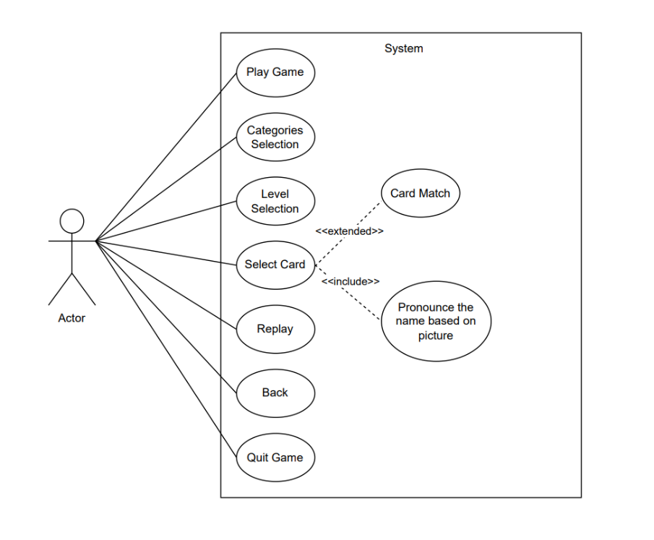

## 5.2. Use Case and Description

|  |  |
| --- | --- |
| Use case | Description |
| Name | Start Screen Navigation |
| Short Description | It describes the process of launching the game and reaching the category selection screen |
| Actors | 1. Child 2. Game System |
| Pre-Condition | The Game is installed and running on a device |
| Trigger | The child wants to start playing the game |
| Main Scenario | 1. The child opens the game application 2. The system displays the start screen with a “Play Game” and “Quit Game” button. 3. The child clicks the “Play Game” button 4. The system loads the learning category selection screen 5. The child sees different learning categories and can choose one 6. The child clicks the “Quite Game” button 7. The game will stop and come out from game interface 8. Use case completed |
| Alternative Scenarios | 1. The child does not press the “Play Game” Button.   a. The system remains idle on the start screen  b. Continue to the category page when child interacts.          2. The child does not press the “Quit Game” Button   * + - 1. The System remains idle on the start screen |
| Special Cases | * 1. The device enters sleep mode while idle on start screen      + App remains paused, resumes without restart. |
| Post - conditions | **Main Scenario:** The game reaches the learning category selection screen.  **Alternative Scenario :** The game remains at  the start screen until the child presses the “Play Game” button. |

|  |  |
| --- | --- |
| **Use case** | **Description** |
| Name | Learning Category Selection |
| Short Description | It describes how the child selects a learning category to explore different themes in the game |
| Actors | 1. Child 2. Game System |
| Pre-Condition | 1. The child has successfully navigated past the start screen 2. The game displays the learning category selection screen |
| Trigger | The child wants to explore a specific category before playing |
| Main Scenario | 1. The system presents multiple learning categories like Tiere, Obst and Gemüse 2. The child views the available categories 3. The child clicks on a desired category 4. The system loads the selected category 5. The child sees the levels related to the chosen category 6. Use case completed |
| Alternative Scenarios | 1. The child does not select a category   a. The system remains idle at the category selection screen.  b. The child can return later and make a selection |
| Special Cases | * 1. Child attempts to tap multiple categories quickly      + System only accepts the first valid input, ignores multiple taps |
| Post - conditions | **Main Scenario:** The selected learning category is successfully loaded. **Alternative Scenario :** The game stays at the category selection screen until the child picks a category. |

|  |  |
| --- | --- |
| **Use case** | **Description** |
| Name | Level Selection |
| Short Description | In this use case describes how the child selects a level to play at the preferred difficulty. |
| Actors | 1. Child 2. Game System |
| Pre-Condition | 1. The child has successfully chosen a learning category 2. The game displays the level selection screen. |
| Trigger | The child wants to select a level before starting the game. |
| Main Scenario | 1. The system presents multiple levels like Easy - level 1 3x4,  Medium - Level 2 4x5, Hard  - Level 3, 5x6 2. The child views the available levels. 3. The child selects a desired level 4. The system loads the selected level 5. The child sees the game board with matching cards 6. Use case completed |
| Alternative Scenarios | 1. The child does  not select a level   a.The system remains idle at the level selection screen  b.The child can return later and make a selection |
| Special cases | 1. Child tries to select a level rapidly multiple times    * + Debounce to avoid multiple load attempts |
| Post - conditions | **Main Scenario:** The selected level is successfully loaded and ready to play.  **Alternative Scenario :** The game stays at the level selection screen until the child picks a level. |

|  |  |
| --- | --- |
| **Use case** | **Description** |
| Name | Back Button for navigation |
| Short Description | It describes how the child can use a back button to return to the previous screen, allowing them to modify their selection or choose a different level. |
| Actors | 1. Child 2. Game System |
| Pre-Condition | 1. The child has navigated to a specific page like go to home page, level selection, category selection. |
| Trigger | The child wants to go back to the previous screen to change their choice. |
| Main Scenario | 1. The child is currently on a screen e.g. level selection 2. The system displays a “Back” button on the interface 3. The child clicks the “Back” button 4. The system returns the child to the previous screen e.g. level selection → categories selection page 5. The child sees their previous choices and can modify them 6. The child selects a new option e.g. different category or level 7. The system loads the updated selection 8. Use case completed |
| Alternative Scenarios | 1. The child does not press the “Back” button   a. The system remains on the current screen  b. The child can continue selecting options or exit the game. |
| Special cases | 1. Child taps back multiple times quickly    * + System processes one back action at a time to prevent unintended exits. |
| Post - conditions | **Main Scenario:** The child successfully navigates back and can modify their selection.  **Alternative Scenario :** The game remains on the same screen until the child decides to navigate back. |

|  |  |
| --- | --- |
| **Use case** | **Description** |
| Name | Card Matching Gameplay |
| Short Description | This use case describes how the child flips cards to reveal images and find matching pairs |
| Actors | 1. Child 2. Game System |
| Pre-Condition | 1. The child has successfully selected a level 2. The game displays a board with face-down cards |
| Trigger | The child wants to start finding matching pairs |
| Main Scenario | 1. The child clicks on a card to flip it 2. The system reveals the image on the card 3. The child clicks another card to flip it 4. The system reveals the second image 5. The system checks if the two images match   If they match :  a.The cards remain flipped  b.The system plays a confirmation sound  c.The child score will increase by 1  If they do not match:  a.the cards will flip back  b.The child continues searching  6.    The process repeats until all pairs are found.  7.    The system confirms level completion and displays a reward  8.    Use case completed |
| Alternative Scenarios | 1. The child does not flip any cards   a.The system remains idle, waiting for user input  b. The child can start playing at any time |
| Special Cases | 1. Child flips the same card twice    * + System ignores the second tap on the same card until another card is selected. |
| Post - conditions | **Main Scenario:** The child successfully finds all matching pairs and completes the level  **Alternative Scenario:** The child can take their time or exit without finishing. |

|  |  |
| --- | --- |
| **Use case** | **Description** |
| Name | Level Replay |
| Short Description | This use case describes how the child can choose to replay a completed level to improve their score or practice more |
| Actors | 1. Child 2. Game System |
| Pre-Condition | 1. The child has completed a level 2. The system has displayed the level completion screen |
| Trigger | The child wants to replay the same level instead of moving forward |
| Main Scenario | 1. The child reaches the level completion screen 2. The system displays options:  * Move to the next level * Replay the same level * Go to the Main Menu   3. The child clicks the “Replay Level” button  4. The system reloads the level with shuffled card positions  5.  The child begins playing the level again  6.  The system tracks the new score separately  7.  Use case completed |
| Alternative Scenarios | 1. The child does not select the replay option 2. The system remains on the level completion screen 3. The child can choose another option later |
| Special Cases | 1. Child repeatedly taps replay button.    * + System allows only one replay action, prevents multiple reloads |
| Post - conditions | **Main Scenario:** The child successfully restarts the level and attempts to improve their score  **Alternative Scenario:** The game remains at the level completion screen until the child chooses another action. |

# 6. Context Analysis

## 6.1 Quantity Structure

|  |  |
| --- | --- |
| **Component** | **Value** |
| Categories | 3 (Animals, Fruits, Vegetables) |
| Levels per category | 3 (Easy, Medium, Hard) |
| Cards per level | 6/9/12 pairs (based on difficulty) |
| Unique cards | ~36 |
| Voice files | ~36 |
| Animations | 3 (flip, match, trophy) |
| Game States | ~5 |
| Sound effects | ~4 |

## 6.2 Dictionary of Terms

|  |  |
| --- | --- |
| **Term** | **Definition** |
| **Player/Child** | The end-user (kid aged 4–6) interacting with the game, flipping cards and progressing through levels. |
| **Card** | An interactive game element with an image and audio pronunciation. Cards are paired for matching. |
| **Card Flip** | An action performed by the player to reveal a card’s content (image and sound). |
| **Match** | A successful pairing of two identical cards. Triggers positive feedback. |
| **Category** | A learning theme (e.g., Animals, Fruits, Vegetables) containing levels and cards. |
| **Level** | A predefined game stage with a specific number of cards and difficulty (Easy, Medium, Hard). |
| **Game** | A complete session initiated by the player, consisting of rounds, levels, and interactions. |
| **Round** | A play-through of one level by the player. A game may include several rounds. |
| **Turn** | A numerical value representing the number of turn pairs. |
| **Visual Feedback** | Animations or effects (like stars, clapping) shown after correct matches or level completion. |
| **Audio Feedback** | Voice pronunciation of cards and sound effects for correct matches or actions. |
| **Trophy/Reward** | A motivational visual (e.g., trophy animation) displayed after level or game completion. |
| **Back Button** | UI control that allows the child to return to a previous screen (e.g., from level to category selection). |
| **Start Screen** | The first screen seen by the player with options to play or quit the game. |
| **Completion Screen** | A summary screen shown at the end of a level offering options to replay, proceed, or exit. |

# 7. Index

Table of Contents

1. Introduction 1

1.1 Purpose 1

1.2 Summary 1

1.3 Definitions and Abbreviations 1

1.4 References, Standards, and Rules 2

1.5 Overview 2

2. Product Vision and Goals 2

2.1 Golden Circle Vision Statement 2

2.2 SMART Goals 2

3. Personas 3

4. User Stories 4

5. Use Cases 5

5.1. Use Case Diagram 5

5.2. Use Case and Description 5

6. Context Analysis 12

6.1 Quantity Structure 12

6.2 Dictionary of Terms 13

7. Index 14